The installation is for Windows 7 (32-Bit) or higher computer.

You will need also Microsoft Office Excel 2013 or higher which installed.

Insert Motor Controller Disk to computer.

Double click on < Disk >\Setup\ setup.exe (see figure below).

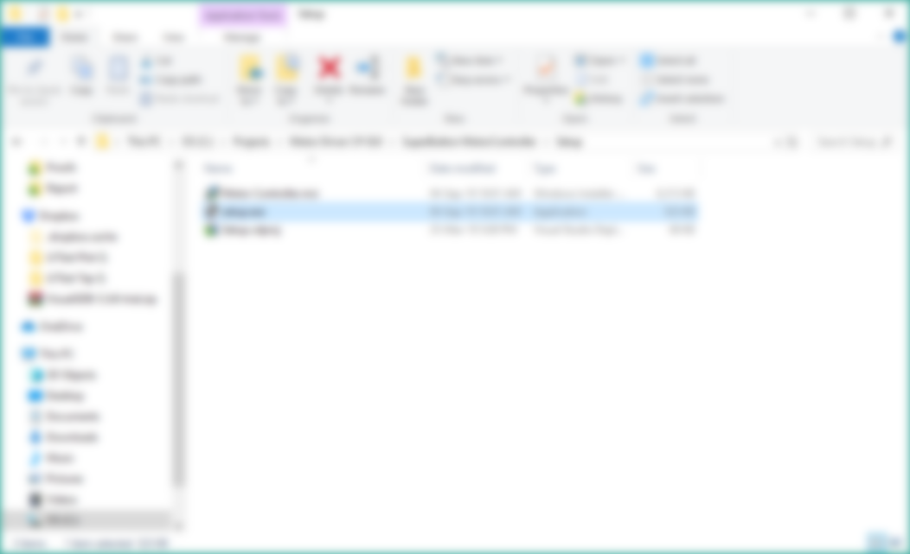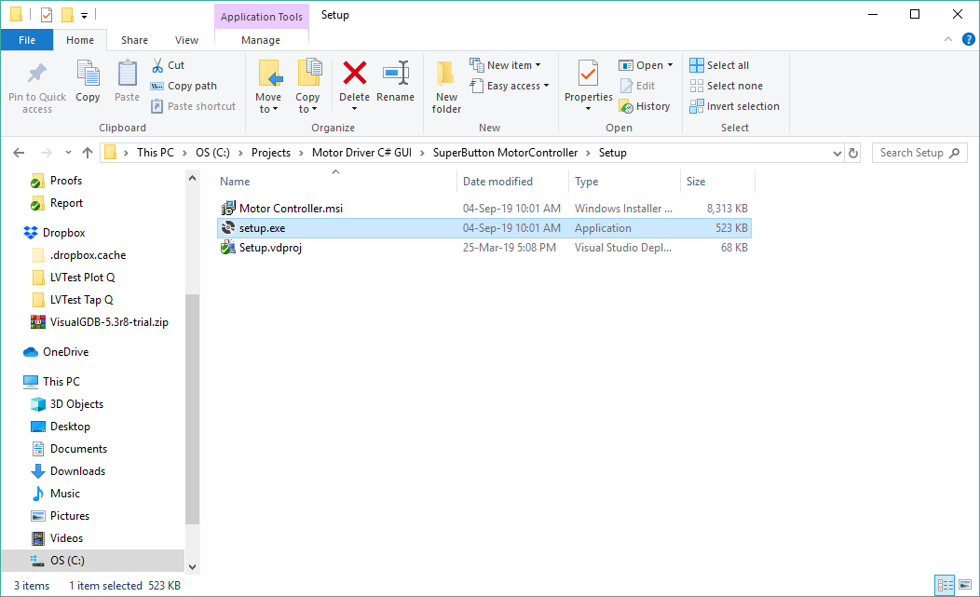

Wait until Windows installer initialization finishes.

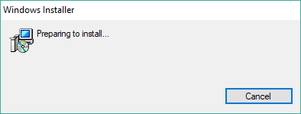

You will be prompted by the figure below, then press Next.

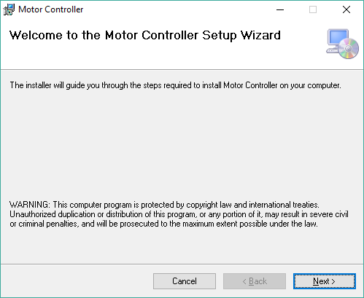

Select the installation folder then press Next to continue.

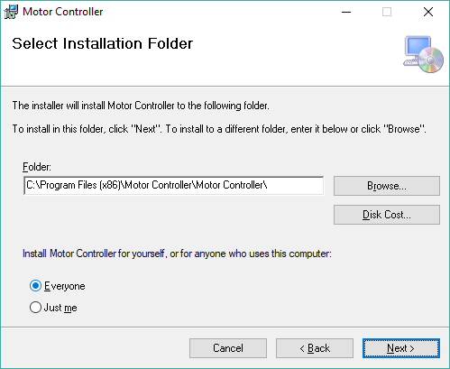

Press Next to confirm installation and continue.

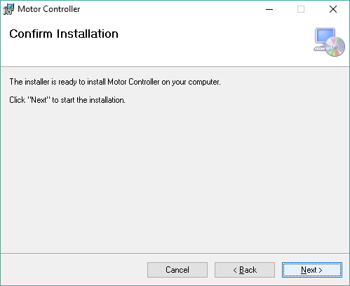

Verify the following screen appears and click “Yes”:

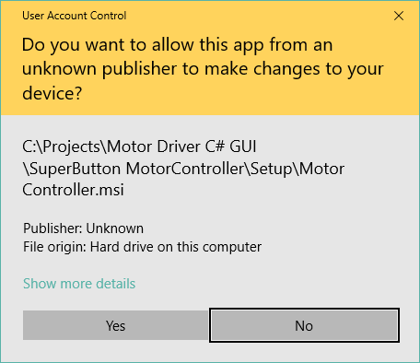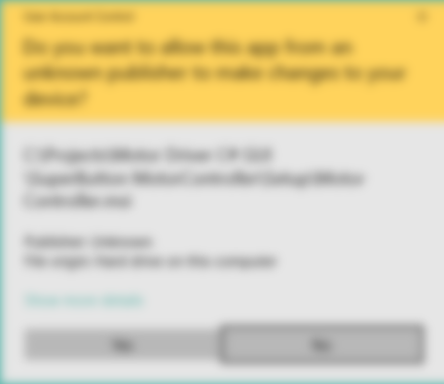

Please wait for end installation.

The loading process takes approximately 1 minute, depend of the computer type.

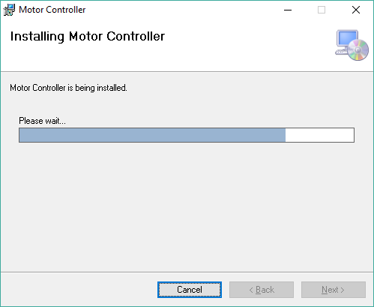

Press Close in Installation Complete window.

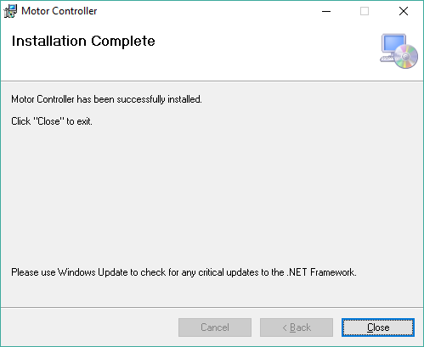

The application shortcut is place in the window menu, under Motor Controller folder, or in the desktop.

See figure below.

Window popup menu:

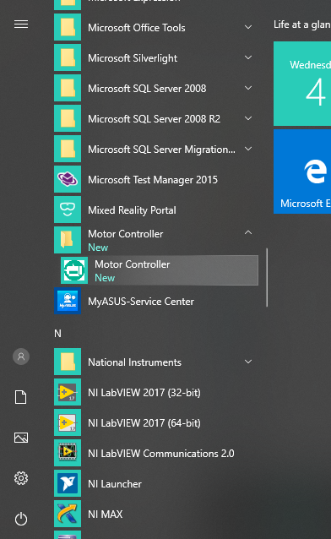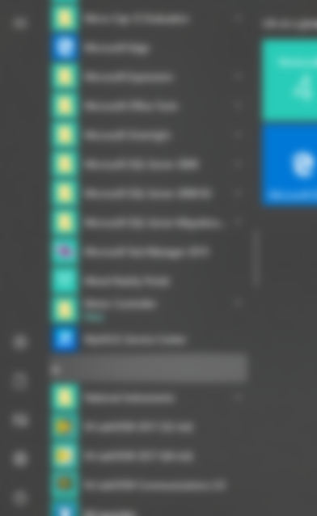

Desktop shortcut application:

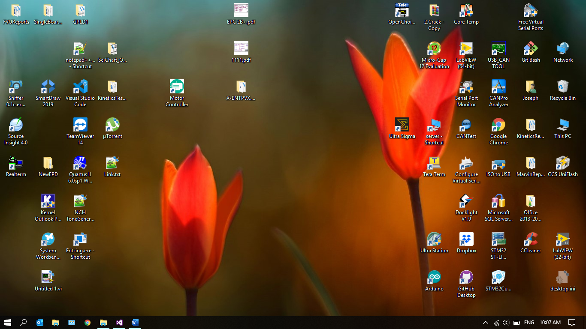

To repair the application, you have to double click on < Disk >\Setup\setup.exe

You will be prompted by the window below.

Go over instruction to complete the process.

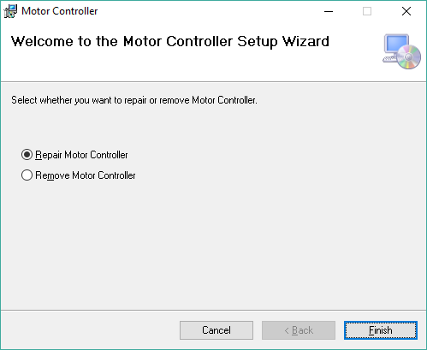

Installation progress window:

Please wait for end installation.

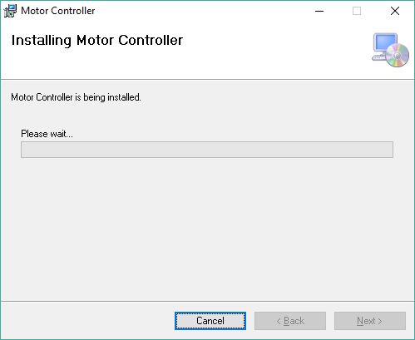

Press Close in Installation Complete window.



To repair the application, you have to double click on < Disk >\Setup\setup.exe

You will be prompted by the window below.

Go over instruction to complete the process.

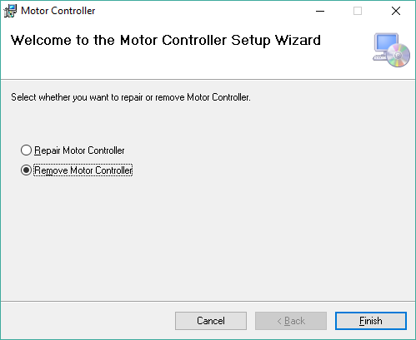

Verify the following screen appears and click “Yes”:



uninstallation progress window:

Please wait for end uninstallation.

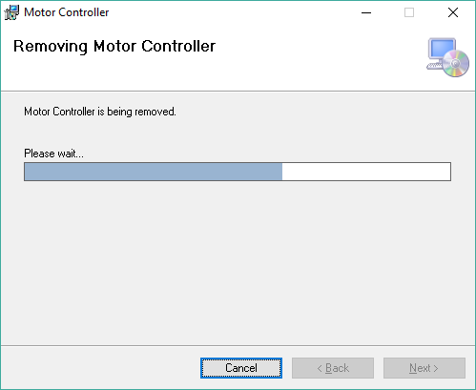

Press Close in uninstallation Complete window.

